**Xining – Enjoying nature and getting refreshed**

**Pleasant climate**

Qinghai Province is a sparking jewel set on the northwest plateau of China, wherein the Yangtze River, the Yellow River as well as the Mekong River take their source. The scenic quality of Qinghai's widely varying landscape is superb and enticing, offering from the ranges of gleaming mountains with glacier-capped peaks over 6000 meters high to the gobi desert dunes of Qaidam, from lush ranchland to the sapphire-like lakes of vast area, all this has created a land of marvel, mystery and diversity.

Xining, located in the northeast of the Qinghai-Tibet Plateau, is the capital of Qinghai Province. Xining has good ecology and pleasant environment. With an average temperature of 18.3℃ in summer, it is known as "Cool City in the World" and "China's Summer Capital". Xining's multi-ethnic population, multi-religious coexistence, and multi-cultural gathering have formed an open and inclusive city and a splendid local customs. It is rich in tourism resources, including the famous Tibetan Buddhism holy site Taer Monastery and Dongguan Mosque. It is only 150 kilometers away from Qinghai Lake, the largest saltwater lake in inland China.

**An ancient city with a long history**

Xining is an ancient city on the plateau with a long history and a cultural component of the Yellow River Basin in China.

|  |  |  |
| --- | --- | --- |
|  | | |
|  |  |  |
|  |  |  |

**Convenient Access**

**By air**

Xining Caojiapu International Airport has domestic flights to Beijing Daxing International Airport, and Beijing Capital International Airport. International flights go to Kuala Lumpur, and Nha Trang. Xining Caojiapu International Airport is a 30 to 40-minute taxi ride from Xining Railway Station.

### By Train

Xining Railway Station links to Lanzhou on bullet train. The tourists can transfer to high-speed rail to Beijing, Shanghai, and Guangzhou.

#### From Beijing to Xining by Train

The trip takes around 11 hours. From Beijing West Railway Station, the tourists can take the high-speed rail to Lanzhou then transfer to the bullet train for Xining.

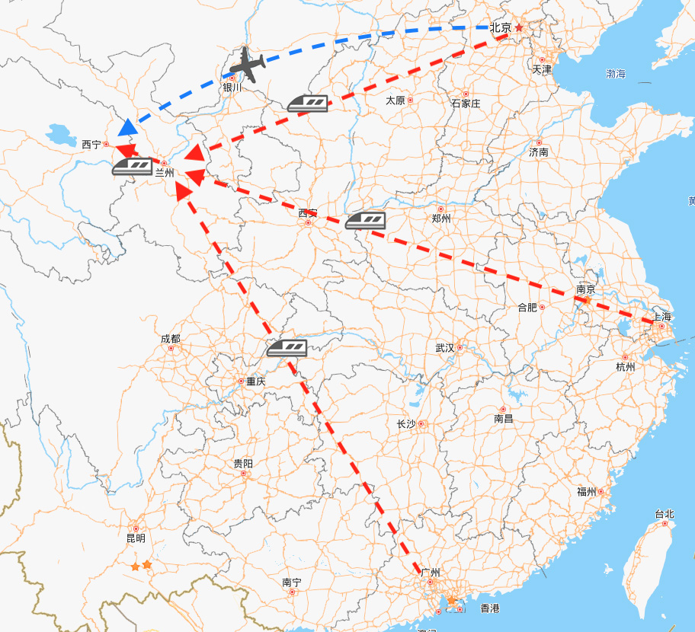

**Conference Venue – Qinghai Hotel YingBin Hall**

* **Professional conference center in Xining**
* **Location:** located in the downtown area, adjacent to the kylin Bay Park. (From the railway station, bus station 5 kilometers away from the airport 28 kilometers)
* **Facilities:** The hotel covers an area of 53067 square meters, with 396 rooms (sets), 19 different sizes of restaurants and 8 different specifications of the conference room, the largest can accommodate 400 people, providing multimedia, network broadband, simultaneous interpretation And other functional services.

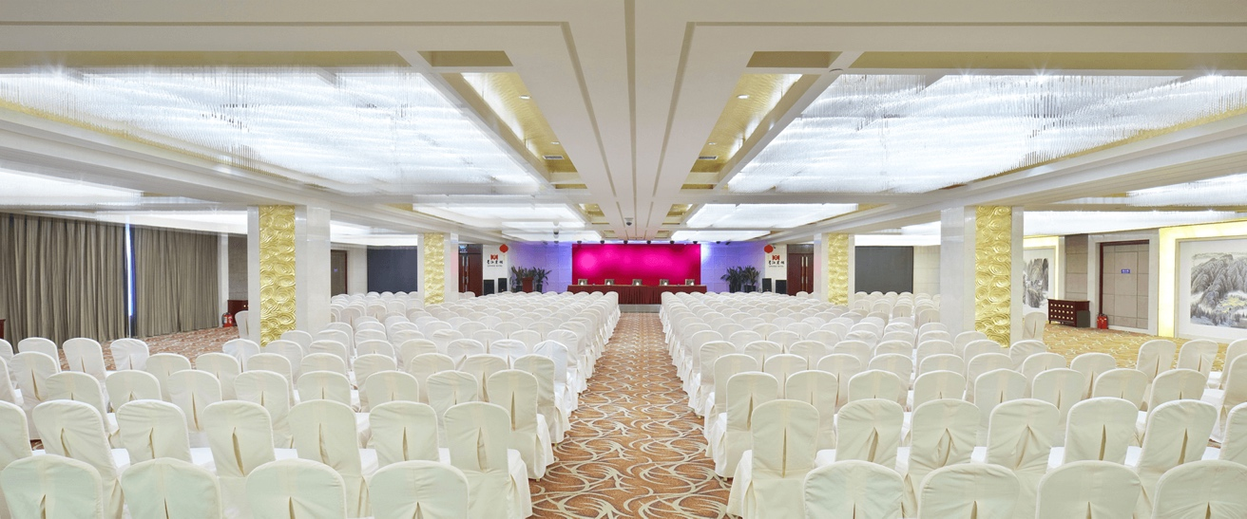

|  |  |
| --- | --- |
|  | |
|  |  |
|  |  |

**Conference Banguet Venue – Qinghai Hotel YingBin Hall**

* The first five-star Hotel in Xining
* **Location:** located in the downtown area, adjacent to the kylin Bay Park. (From the railway station, bus station 5 kilometers away from the airport 28 kilometers)
* **Facilities:** The hotel has 396 rooms (sets), 19 different sizes of restaurants and 8 different specifications of the conference room, the largest can accommodate 400 people.

|  |  |
| --- | --- |
|  |  |
|  | |

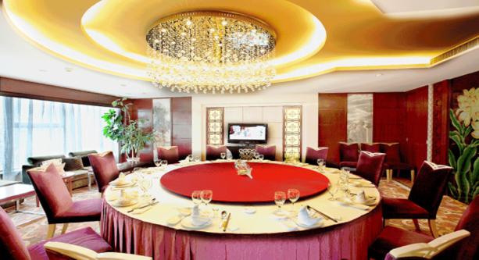 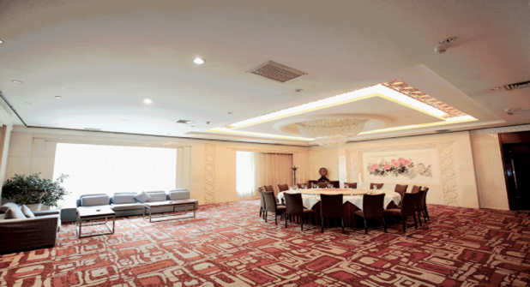

**Conference website:**

www.ieee-rcar.org

